ImageImage

**Breaking through**

**Barriers**

Breaking through Barriers

AMERICAN ASSOCIATION OF UNIVERSITY WOMEN

SOUTH LAKE TAHOE BRANCH

https://southlaketahoe-ca.aauw.net

www.facebook.com/sltbranch

For additional information contact:

Jeanne Benin

AAUW South Lake Tahoe Branch

PO Box 10030

South Lake Tahoe, CA 96158

530-541-1371

[jlbenin@charter.net](mailto:jlbenin@charter.net)

AAUW

South Lake Tahoe Branch

The South Lake Tahoe California Branch has been active since 1964. We uphold the goals of our national and state organizations and strive to design and offer programs, events and philanthropies that are relevant to the needs, interests and betterment of our local south shore community.

Monthly branch meetings provide interesting, topical and educational programs, and are open to the public, as well as members. The meeting times and locations can be found on our website, our Facebook page and in our monthly newsletter Women’s Words.

Additionally, branch members are encouraged to participate in any of our interest groups which include:

Book Club, Social Justice Book Club

Let’s Go to the Movies

Great Decisions Study Group

Talking on Paper

Cocktails and Convos

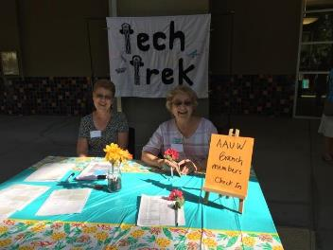

Mission Statement

AAUW advances equity for women and girls through advocacy, education, philanthropy and research.

Value Promise

[www.aauw.org](http://www.aauw.org)

www.aauw-ca.org

American Association of University Women (AAUW) is a nationwide network of more than 170,000 members and donors. Since 1881 AAUW members have examined and taken positions on the fundamental issues of the day - educational, social, economic and political. Our commitment to our mission is reflected in all aspects of our work. Membership in AAUW offers exceptional tangible and intangible benefits - a strong voice, a vibrant community, relevant information and valuable resources.

By joining AAUW, you belong to a community that breaks. Through educational barriers so that all women have a fair chance.

AAUW is an incredible value: representation, community, information, education and inspiration. You can find it all as part of AAUW.

By joining AAUW, you belong to a community that breaks through educational and economic barriers so that *all* women have a fair chance.

In principle and in practice, AAUW values and seeks a diverse membership. There are no barriers to full participation in this organization on the basis of gender, race, national origin, creed, age, sexual orientation, disability or class.

No special invitation is. needed to join AAUW. Individuals eligible to be admitted to membership are those holding an associate or equivalent, baccalaureate or equivalent higher degree from a college or university.

Student memberships and associate memberships are also available.